**Matplotlib Exercises - 1**

**1.** Write a Python program to draw a line with suitable label in the x axis, y axis and a title.   
The code snippet gives the output shown in the following screenshot:  
  
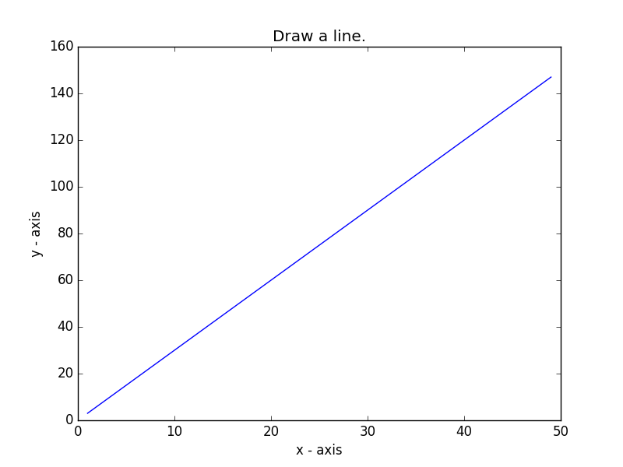

**2.** Write a Python program to draw a line using given axis values with suitable label in the x axis , y axis and a title.    
The code snippet gives the output shown in the following screenshot:  
  
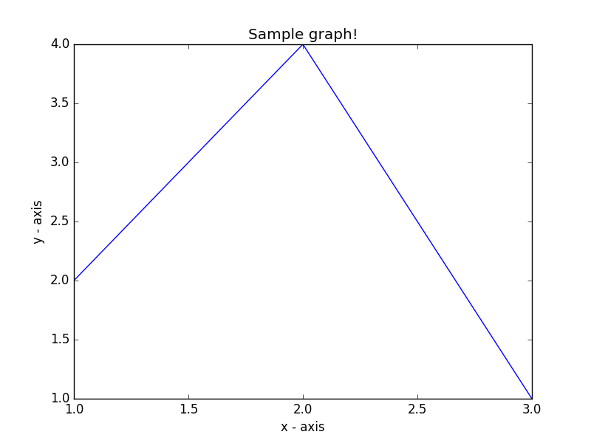

**3.** Write a Python program to draw a line using given axis values taken from a text file, with suitable label in the x axis, y axis and a title. 

*Test Data:* test.txt  
1 2  
2 4  
3 1  
The code snippet gives the output shown in the following screenshot:  
  


**4.**Write a Python program to draw line charts of the financial data of Alphabet Inc. between October 3, 2016 to October 7, 2016.    
**Sample Financial data (fdata.csv):**Date,Open,High,Low,Close  
10-03-16,774.25,776.065002,769.5,772.559998  
10-04-16,776.030029,778.710022,772.890015,776.429993  
10-05-16,779.309998,782.070007,775.650024,776.469971  
10-06-16,779,780.47998,775.539978,776.859985  
10-07-16,779.659973,779.659973,770.75,775.080017  
The code snippet gives the output shown in the following screenshot:  
  
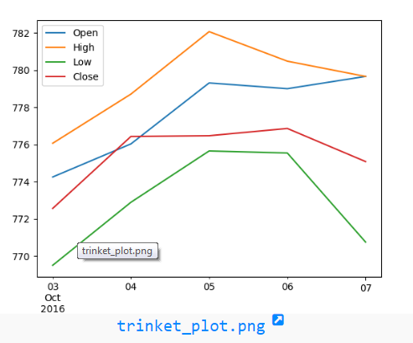

**5.** Write a Python program to plot two or more lines on same plot with suitable legends of each line.   
The code snippet gives the output shown in the following screenshot:  
  
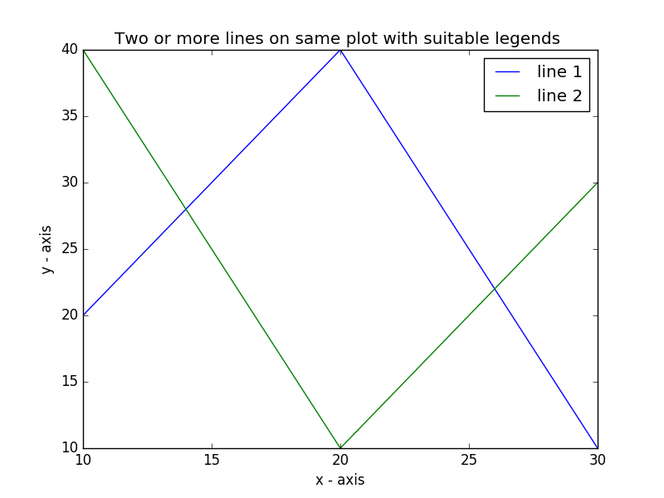

**6.** Write a Python program to plot two or more lines with legends, different widths and colors.   
The code snippet gives the output shown in the following screenshot:  
  
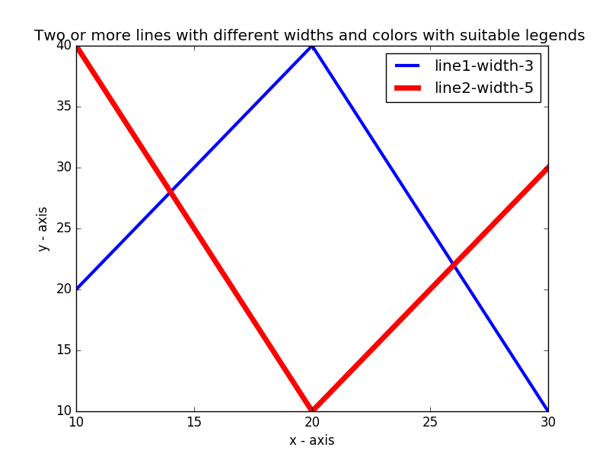

**7.** Write a Python program to plot two or more lines with different styles.    
The code snippet gives the output shown in the following screenshot:  
  
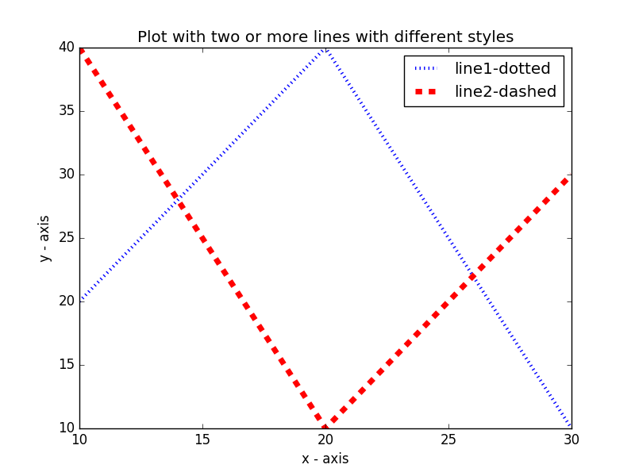

**8.**Write a Python program to plot two or more lines and set the line markers   
The code snippet gives the output shown in the following screenshot:  
  
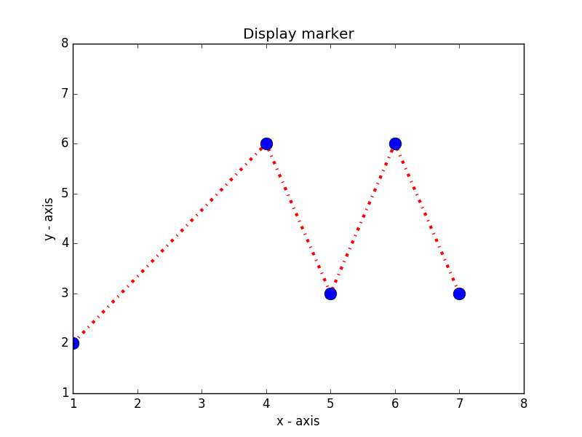

**9.** Write a Python program to display the current axis limits values and set new axis values   
The code snippet gives the output shown in the following screenshot:  
  
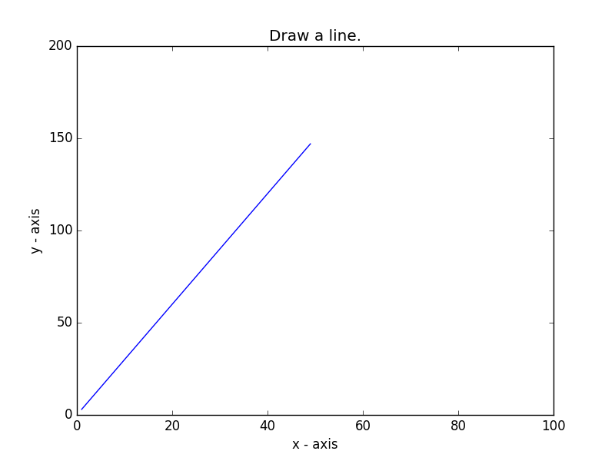

**Matplotlib Exercises - 2**

**1.** Write a Python programming to display a bar chart of the popularity of programming Languages.   
**Sample data:**  
Programming languages: Java, Python, PHP, JavaScript, C#, C++  
Popularity: 22.2, 17.6, 8.8, 8, 7.7, 6.7  
The code snippet gives the output shown in the following screenshot:  
  
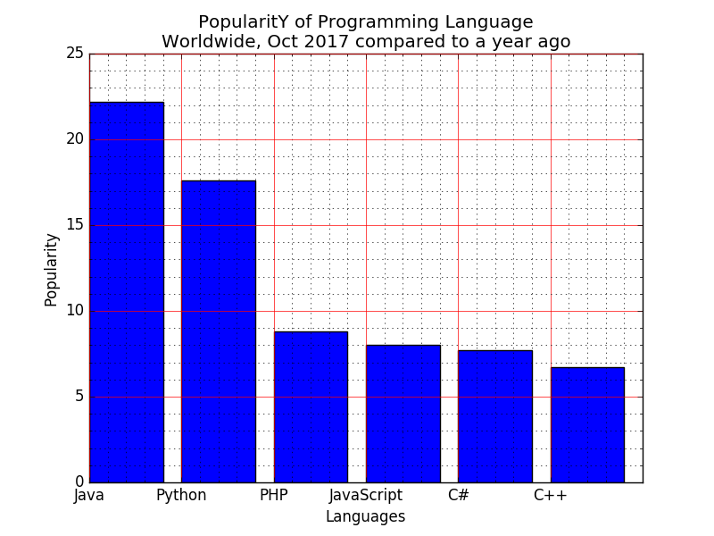

**2.** Write a Python programming to display a horizontal bar chart of the popularity of programming Languages.    
**Sample data:**Programming languages: Java, Python, PHP, JavaScript, C#, C++  
Popularity: 22.2, 17.6, 8.8, 8, 7.7, 6.7  
The code snippet gives the output shown in the following screenshot:  
  
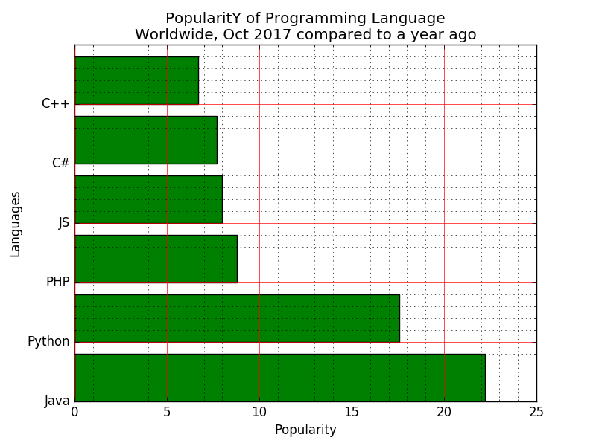

**3.** Write a Python programming to display a bar chart of the popularity of programming Languages. Use uniform color.

**Sample data:**Programming languages: Java, Python, PHP, JavaScript, C#, C++  
Popularity: 22.2, 17.6, 8.8, 8, 7.7, 6.7  
The code snippet gives the output shown in the following screenshot:  
  
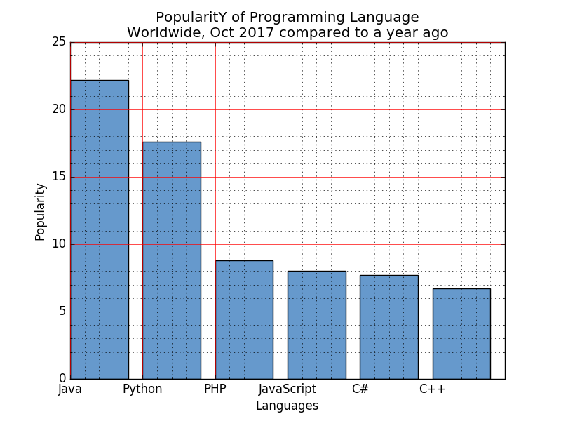

**4.** Write a Python programming to display a bar chart of the popularity of programming Languages. Use different color for each bar.    
**Sample data:**Programming languages: Java, Python, PHP, JavaScript, C#, C++  
Popularity: 22.2, 17.6, 8.8, 8, 7.7, 6.7  
  
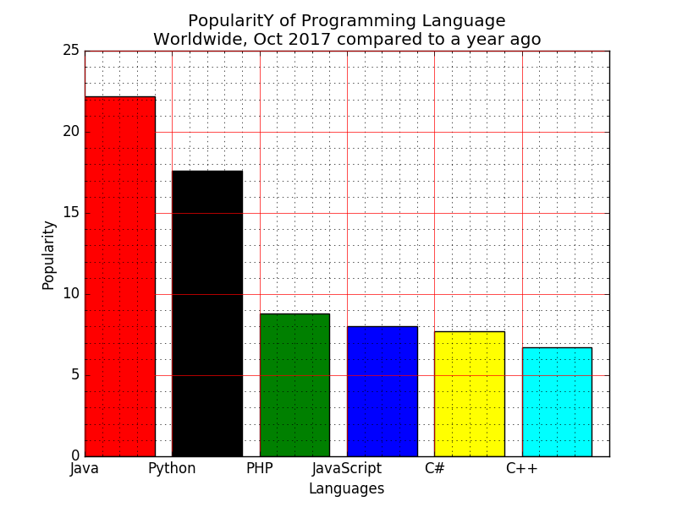

**5.** Write a Python programming to display a bar chart of the popularity of programming Languages. Attach a text label above each bar displaying its popularity (float value).    
**Sample data:**Programming languages: Java, Python, PHP, JavaScript, C#, C++  
Popularity: 22.2, 17.6, 8.8, 8, 7.7, 6.7  
The code snippet gives the output shown in the following screenshot:  
  
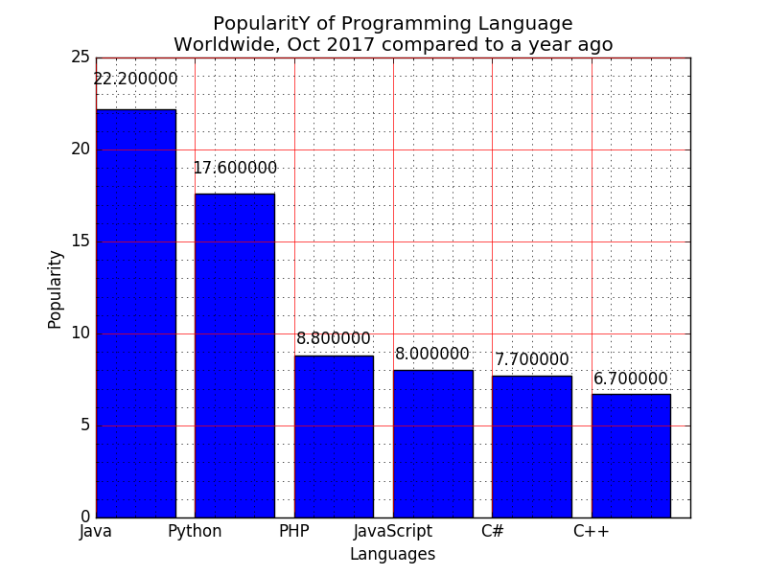

**6.** Write a Python programming to display a bar chart of the popularity of programming Languages. Make blue border to each bar.    
**Sample data:**Programming languages: Java, Python, PHP, JavaScript, C#, C++  
Popularity: 22.2, 17.6, 8.8, 8, 7.7, 6.7  
The code snippet gives the output shown in the following screenshot:  
  
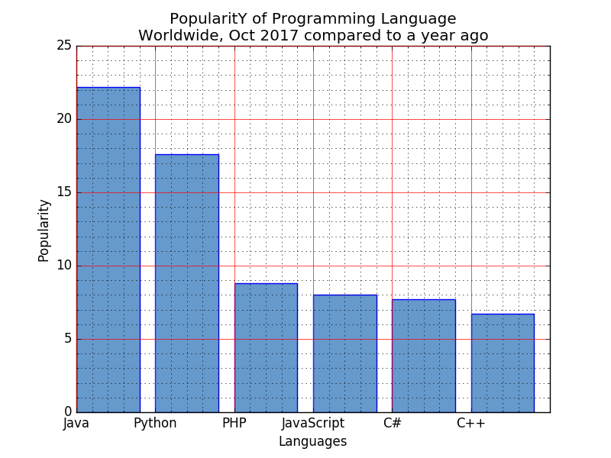

**7.** Write a Python programming to display a bar chart of the popularity of programming Languages. Specify the position of each bar plot.   
**Sample data:**Programming languages: Java, Python, PHP, JavaScript, C#, C++  
Popularity: 22.2, 17.6, 8.8, 8, 7.7, 6.7  
The code snippet gives the output shown in the following screenshot:  
  
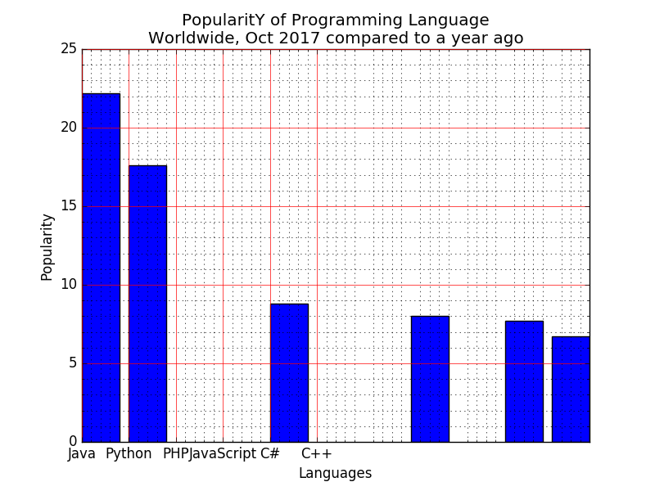

**8.** Write a Python programming to display a bar chart of the popularity of programming Languages. Select the width of each bar and their positions.

**Sample data:**Programming languages: Java, Python, PHP, JavaScript, C#, C++  
Popularity: 22.2, 17.6, 8.8, 8, 7.7, 6.7  
The code snippet gives the output shown in the following screenshot:  
  
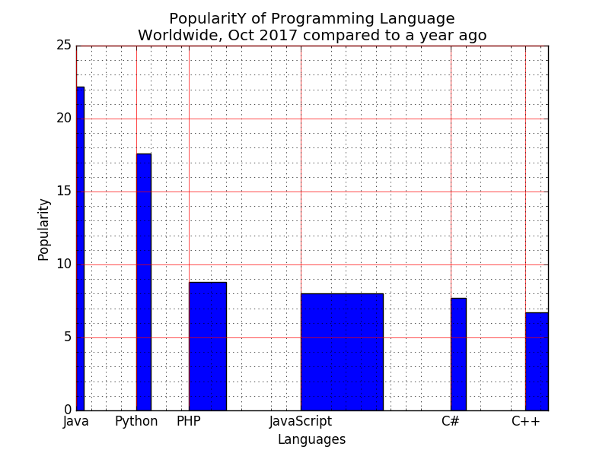

**9.** Write a Python programming to display a bar chart of the popularity of programming Languages. Increase bottom margin.    
**Sample data:**Programming languages: Java, Python, PHP, JavaScript, C#, C++  
Popularity: 22.2, 17.6, 8.8, 8, 7.7, 6.7  
The code snippet gives the output shown in the following screenshot:  
  
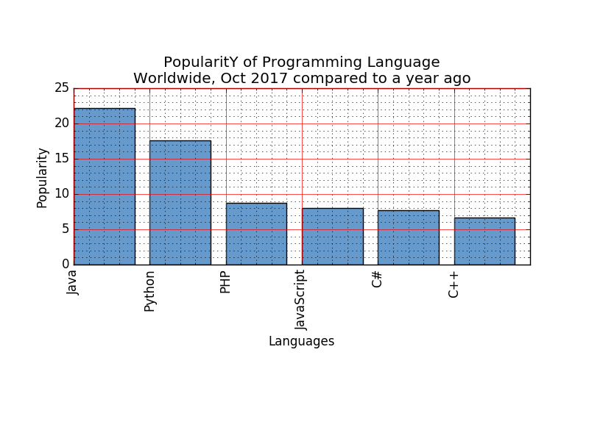

**10.** Write a Python program to create bar plot of scores by group and gender. Use multiple X values on the same chart for men and women.  
**Sample Data:**Means (men) = (22, 30, 35, 35, 26)  
Means (women) = (25, 32, 30, 35, 29)  
The code snippet gives the output shown in the following screenshot:  
  
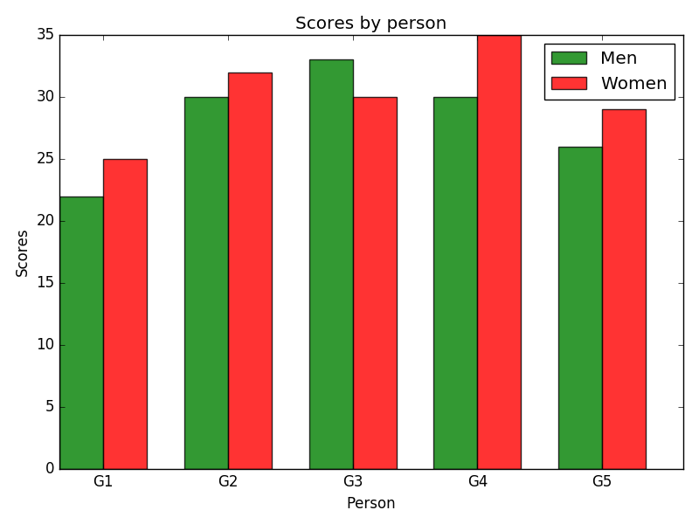

**11.** Write a Python program to create bar plot from a DataFrame.   
Sample Data Frame:  
a b c d e  
2 4,8,5,7,6  
4 2,3,4,2,6  
6 4,7,4,7,8  
8 2,6,4,8,6  
10 2,4,3,3,2  
The code snippet gives the output shown in the following screenshot:  
  
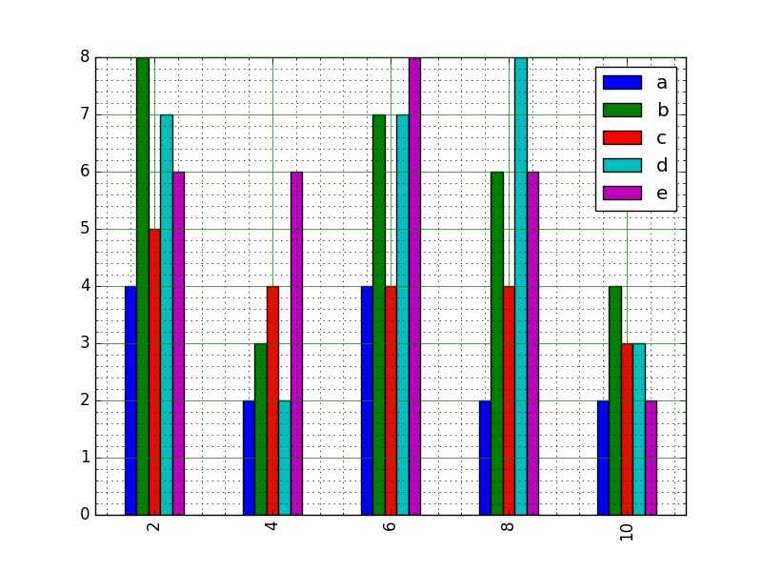

**12.** Write a Python program to create bar plots with error bars on the same figure.    
**Sample Date**Mean velocity: 0.2474, 0.1235, 0.1737, 0.1824  
Standard deviation of velocity: 0.3314, 0.2278, 0.2836, 0.2645  
The code snippet gives the output shown in the following screenshot:  
  
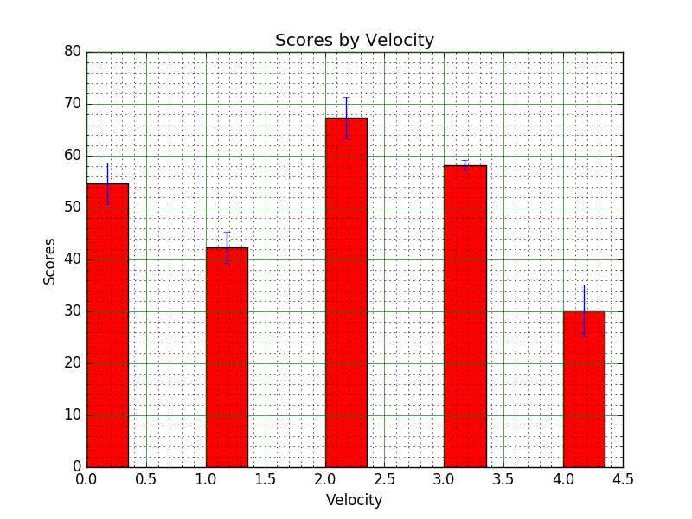

**13.**Write a Python program to create bar plots with errorbars on the same figure. Attach a text label above each bar displaying men means (integer value).   
**Sample Data**Mean velocity: 0.2474, 0.1235, 0.1737, 0.1824  
Standard deviation of velocity: 0.3314, 0.2278, 0.2836, 0.2645  
The code snippet gives the output shown in the following screenshot:  
  
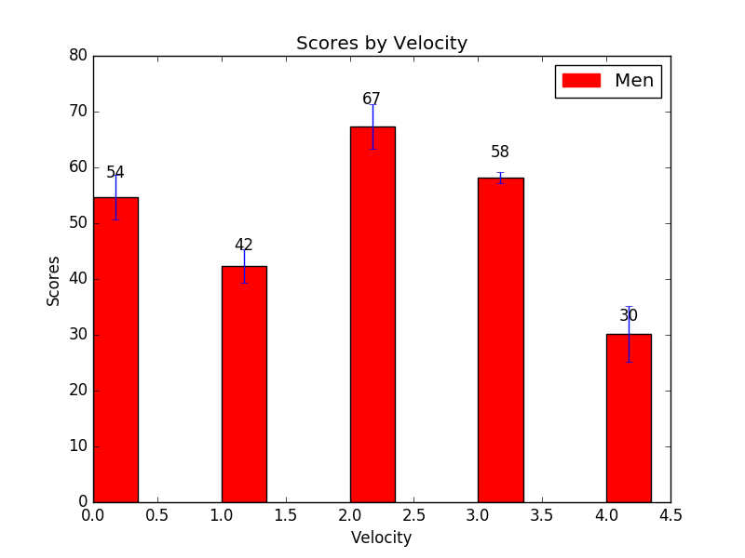

**14.**Write a Python program to create a stacked bar plot with error bars.    
Note: Use bottom to stack the women?s bars on top of the men?s bars.  
**Sample Data:**Means (men) = (22, 30, 35, 35, 26)  
Means (women) = (25, 32, 30, 35, 29)  
Men Standard deviation = (4, 3, 4, 1, 5)  
Women Standard deviation = (3, 5, 2, 3, 3)  
The code snippet gives the output shown in the following screenshot:  
  
